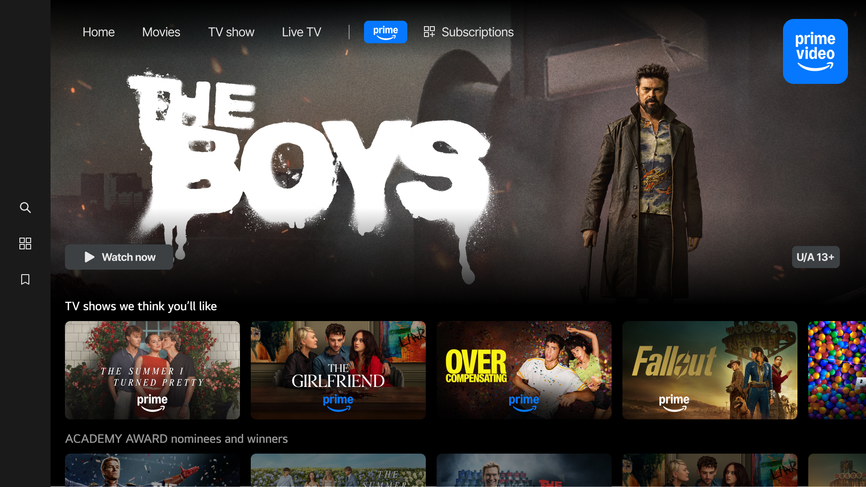

LG BRINGS PRIME VIDEO TO
AUTOMOTIVE CONTENT PLATFORM

First-Stop Entertainment Destination Being Integrated
With LG’s Automotive Content Platform in 2026

LAS VEGAS, Jan. 6, 2026 — Mobility technology leader LG Electronics will integrate Prime Video into the LG Automotive Content Platform (ACP) in 2026. LG will showcase the LG ACP to the public as part of its Best of Innovation Award-winning solutions at CES® 2026, which opened in Las Vegas today.

Automakers with the LG ACP will be able to offer Prime Video’s broad selection of popular movies, series, live events and exclusive Prime Originals for the first time beginning in the second quarter of 2026.

“Optimized for the in-car environment, LG ACP enables passengers to immerse themselves in their favorite content from Prime Video and other providers – just like they would at home on LG’s popular webOS smart TV platform,” said Jae Byun, president of LG Electronics Vehicle Solution USA.
Emily Aldis, Prime Video’s Director of Devices and AI Partnerships, said, “Bringing Prime Video’s vast collection of premium entertainment to even more customers through the LG ACP represents our continued commitment to meeting customers wherever they are with seamless access to their favorite content. LG’s innovative approach to in-vehicle entertainment aligns perfectly with our vision of making Prime Video accessible across all screens and experiences.”

The LG ACP is an advanced new approach to vehicle entertainment systems, which in turn is part of the LG AlphaWare software suite that is transforming vehicles into “living spaces on wheels.” The webOS-based LG ACP is designed to deliver seamless in-car experiences and provide intuitive access to essential information and services through popular apps.*

Byun said the LG ACP enhances the in-vehicle infotainment experience through the delivery of high-resolution content and superior audio quality. “LG is committed to offer customers the best webOS entertainment experience, regardless if they are at home or on the go,” he added.

For more information on LG’s vehicle solutions and LG AlphaWare, visit www.LG.com/ global/mobility.

* A subscription is required to access apps. Apps available on LG ACP may vary by region. The availability of apps may be subject to change or discontinuation.

# # #

About the LG Electronics Vehicle Solution Company
The LG Vehicle Solution (VS) Company is bringing LG Electronics’ unique human-centered innovations to the automotive industry. As a trusted and innovative partner, the company provides intelligent solutions including head units, displays, connectivity, ADAS vision systems, and software solutions for software-defined vehicles. Committed to “Driving Better Future Mobility,” the company has diversified its portfolio to further strengthen its capabilities, including automotive lighting systems, e-powertrain, and cybersecurity. For more information, visit www.LG.com/global/mobility. To stay up to date with the latest news, subscribe to the LG mobility newsletter, LG Loop, at www.LG.com/global/mobility/newsletter and follow the LG VS Company LinkedIn channel at www.linkedin.com/company/lgvehiclesolution.

About LG Vehicle Components USA
Based in Troy, Mich., LG Electronics Vehicle Components USA is the U.S. engineering and sales organization under the LG Electronics Vehicle Solution Company, which brings human-centric innovations to the automotive industry. In the United States, the company provides intelligent solutions including in-vehicle infotainment, display, connectivity and ADAS, as well as platforms for Software Defined Vehicles and the AI-Defined Vehicles of the future. www.LG.com/global/mobility.

Media Contact:

LG Electronics USA
John I. Taylor
+1 201 816 2166
john.taylor@lge.com
www.LG.com

